Getting started
Welcome to Genomica de Poblaciones y RAD-Seq!
During our first week of the ddRAD-seq Workshop, we will focus on using a bioinformatics pipeline to process ddRAD-seq data. We will use the pipeline from: DaCosta JM, Sorenson MD (2014) Amplification biases and consistent recovery of loci in a double-digest RAD-seq protocol. PLoS One, 9, e106713.
During the second week, we will analyze ddRAD-seq data to make inferences about populations.
We will be using the following five programs. It is strongly recommended that you download and install all programs prior to the start of the course. I also suggest creating a folder named “PopGen” where you will keep all the documents for this course.
- Python3
  - The scripts for this pipeline are written for a Linux version of Python3. If you are not running Linux on your computer, you can use a Windows-based Python3, which is available here: https://www.python.org/downloads/windows/ Some steps of the pipeline do not work correctly in the Windows version, but in those cases, I can provide you with the output.
  - Go to https://www.python.org/downloads/windows/
  - Select Latest Python 3 Release - Python 3.11.4
  - Scroll to the bottom of the page, and select Windows installer (64-bit) (depending on the bit-version on your computer, you might need Windows installer (32-bit)).
    - To check, click on the Start button then choose Settings.
    - Click on System.
    - Under System, choose About.
    - You will be able to see the bit-version on the System type field.
  - Download the file and execute (double-click on the exe file)
  - Follow the installation instructions

- R for Windows
  - Note that distributions are available for Windows, Mac, and Linux, but I have only used the Windows version.
  - Go to https://www.r-project.org/
  - Click “download R” and choose the mirror for Colombia (Icesi University)
  - Choose “Download R for Windows” (or “…(Mac) OS X” or “Linux”, depending on your operating system”), and then “install R for the first time”.
  - Choose “Download R 4.3.1 for Windows” and Save File.
  - Execute the file “R-4.3.1-win.exe”.
  - Go through the steps, leaving the default options checked, to install the program. Once it finishes, click “Finish”. (Additional help can be found by clicking the link “Installation and other instructions” located below the “Download R 4.3.1 for Windows” link on the website.
  - Execute R
  - Type install.packages("adegenet") on the command line
    - If you get the error, “lib = "C:/Program Files/R/R-3.6.0/library"' is not writable”, then you will need to restart R with administrator privileges. To do so, close R and right-click on the R icon and choose “Run as administrator”.
  - Once this package is installed, you will be ready for data analysis.

- BayeScan
  - Go to http://cmpg.unibe.ch/software/BayeScan/
  - Click on Download from the blue bar at the top of the screen
  - Scroll down and click on the icon to download:
  - Move the downloaded file “BayeScan2.1.zip” to your PopGen folder.
  - Unzip the folder: right click on the folder and select “Extract all…”
  - You should now be ready to use BayeScan

- STRUCTURE https://web.stanford.edu/group/pritchardlab/structure_software/release_versions/v2.3.4/html/structure.html
  - Download package with graphical front end: For Windows XP/Vista/Windows 7 : [Windows] (Mac OS X and Linux are also available, but I have not used those)
  - Move the downloaded file, Structure.msi, to your PopGen folder
  - Double-click on Structure.msi to begin the installation process
  - Follow the instructions to complete installation

- starBEAST2
  - Install BEAST2
    - Go to http://www.beast2.org/
    - Scroll down to “Download for Windows” and choose “with java (45MB)” [If you already have the most recent version of java installed, you can choose “without java (8MB)”
    - This will download a zipped folder: BEAST_with_JRE.v2.6.7.Windows.zip
    - Move this folder to your PopGen folder
    - Unzip the folder: right click on the folder and select “Extract all…”
  - Install starBEAST2
    - Open the folder “BEAST_with_JRE.v2.6.7.Windows”
    - Open the folder “BEAST”
    - Execute the file “BEAUti.exe” by double-clicking on the icon
    - If you get the following warning, click on “More info” and click “Run anyway”:
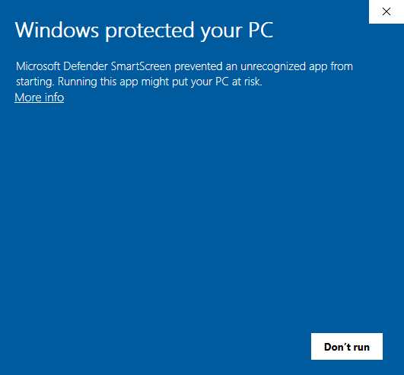
    - Open the File menu and select Manage Packages
    - Select StarBEAST2 from the list of available packages and click the install button
    - BEAUti must be restarted to complete the installation of StarBEAST2

